Sentimental Questions:

Easy:

Q1: “NVIDIA stock surged after analysts raised their price target, citing strong demand for AI chips.”

Q2: “$AAPL to the moon! Their new M4 chip just crushed everything else”

Q3: “Tesla faces another investigation over safety issues related to its autopilot system.”

Q4: “Why does $NFLX keep hiking prices? Canceling my subscription again.”

Q5: “We remain confident in our long-term growth strategy, supported by solid demand across all business segments.”

Medium:
- Q6: “Microsoft announced a partnership with a cloud startup to expand its AI services, but financial impact remains unclear.”

Q7: “While the quarter was challenging due to supply constraints, we expect gradual recovery in the next half.”
- Q8: “Amazon’s profit margins declined for the third consecutive quarter despite rising overall revenue.”
- Q9: “Our R&D investments will slightly impact margins this year but position us for stronger growth next year.”
- Q10: “Not sure what to think about $META earnings. Feels like they’re spending too much on the metaverse.”
- Q11: “Stock market today: Dow, S&P 500, Nasdaq end volatile week lower amid worst tech sell-off since April”
Hard：
- Q12: “Customer churn increased significantly this quarter, primarily due to product performance issues.”
- Q13:“$TSLA just dropped 7% today… guess the hype is finally over.”
- Q14:“Apple’s quarterly earnings beat analyst expectations, driven by strong iPhone sales and growing service revenue.”
- Q15: “Despite revenue growth, we failed to meet profitability targets due to higher operational expenses.”
- Q16: “Everyone keeps hyping $AMZN drones, but until they deliver to my door, it’s just talk.”

Question type:
- Equity News Sentiment, ENS
- Equity Social Media Sentiment, ESM
- Equity Transcript Sentiment, ETS
- ES News Sentiment, ES-ESG
- Country News Sentiment, CNS

FinGPT’s Accuracy: 13 out of 16 (81.3%)
Perplexity’s Accuracy: 12 out of 16 (75%)
Task | FinGPT | Perplexity
Easy(5) | 5, 100% | 3, 60%
Medium(6) | 3, 50% | 5, 83.3%
Hard(5) | 5, 100% | 4,80%
Total (16) | 13, 81.3% | 12, 75%

Easy:

Q1: “NVIDIA stock surged after analysts raised their price target, citing strong demand for AI chips.” (Type: ENS)
Truth: Positive

FinGPT: Positive(correct)
Perplexity: Positive(correct)

Q2:“$AAPL to the moon! Their new M4 chip just crushed everything else” (Type: ESM)
Truth: Positive

FinGPT: Positive(correct)
Perplexity: Positive(correct)

Q3:“Tesla faces another investigation over safety issues related to its autopilot system.” (Type: ES-ESG)
Truth: Negative

FinGPT: Negative(correct)
Perplextity: Neutral ( incorrect )

Q4:“Why does $NFLX keep hiking prices? Canceling my subscription again.” (Type: ESM)
Truth: Negative

FinGPT: Negative(correct)
Perplexity: Neutral ( incorrect )

Q5:“We remain confident in our long-term growth strategy, supported by solid demand across all business segments.” (Type: ETS)

Truth: Positive

FinGPT: Positive(correct)
Perplexity: Positive(correct)

Medium:

Q6: “Microsoft announced a partnership with a cloud startup to expand its AI services, but financial impact remains unclear.” (Type: ENS)
Truth: Neutral

FinGPT: Neutral(correct)
Perplexity: Neutral(correct)

Q7: “While the quarter was challenging due to supply constraints, we expect gradual recovery in the next half.” (Type: ETS)
Truth: Neutral

FinGPT: Positive(incorrect)
Perplexity: Neutral(correct)

Q8: “Amazon’s profit margins declined for the third consecutive quarter despite rising overall revenue.” (Type: ENS)
Truth: Negative

FinGPT: Negative(correct)
Perplexity: Negative(correct)

Q9: “Our R&D investments will slightly impact margins this year but position us for stronger growth next year.” (Type: ETS)
Truth: Neutral

FinGPT: Positive(incorrect)
Perplexity: Neutral(correct)

Q10: “Not sure what to think about $META earnings. Feels like they’re spending too much on the metaverse.” (Type: ESM)
Truth: Neutral

FinGPT: Negative(incorrect)
Perplexity: Negative(incorrect)

Q11: “Stock market today: Dow, S&P 500, Nasdaq end volatile week lower amid worst tech sell-off since April” (Type: CNS)
Truth: Negative

FinGPT: Negative(correct)
Perplexity: Negative(correct)

Hard:

Q12: “Customer churn increased significantly this quarter, primarily due to product performance issues.” (Type: ETS)
Truth: Negative

FinGPT: Negative(correct)
Perplexity: Negative(correct)

Q13: “$TSLA just dropped 7% today… guess the hype is finally over.” (Type: ESM)
Truth: Negative

FinGPT: Negative(correct)
Perplexity: Negative(correct)

Q14: “Apple’s quarterly earnings beat analyst expectations, driven by strong iPhone sales and growing service revenue.” (Type: ENS)
Truth: Positive
FinGPT: Positive(correct)
Perplexity: Positive(correct)

Q15: “Despite revenue growth, we failed to meet profitability targets due to higher operational expenses.” (Type: ETS)
Truth: Negative

FinGPT: Negative (correct)
Perplexity: Negative(correct)

Q16: “Everyone keeps hyping $AMZN drones, but until they deliver to my door, it’s just talk.” (Type: ESM)
Truth: Negative

FinGPT: Negative(correct)
Perplexity: Neutral（incorrect）

Failure Cases

Q7: “While the quarter was challenging due to supply constraints, we expect gradual recovery in the next half.” (Type: ETS)
Truth: Neutral

FinGPT: Positive(incorrect)

Q9: “Our R&D investments will slightly impact margins this year but position us for stronger growth next year.” (Type: ETS)
Truth: Neutral

FinGPT: Positive(incorrect)

Q10: “Not sure what to think about $META earnings. Feels like they’re spending too much on the metaverse.” (Type: ESM)
Truth: Neutral

FinGPT: Negative(incorrect)

Question1: What will be the Largest Company at the end of November 2025?
Truth: NVIDIA with about 97% support rate at Nov 4th 6:51pm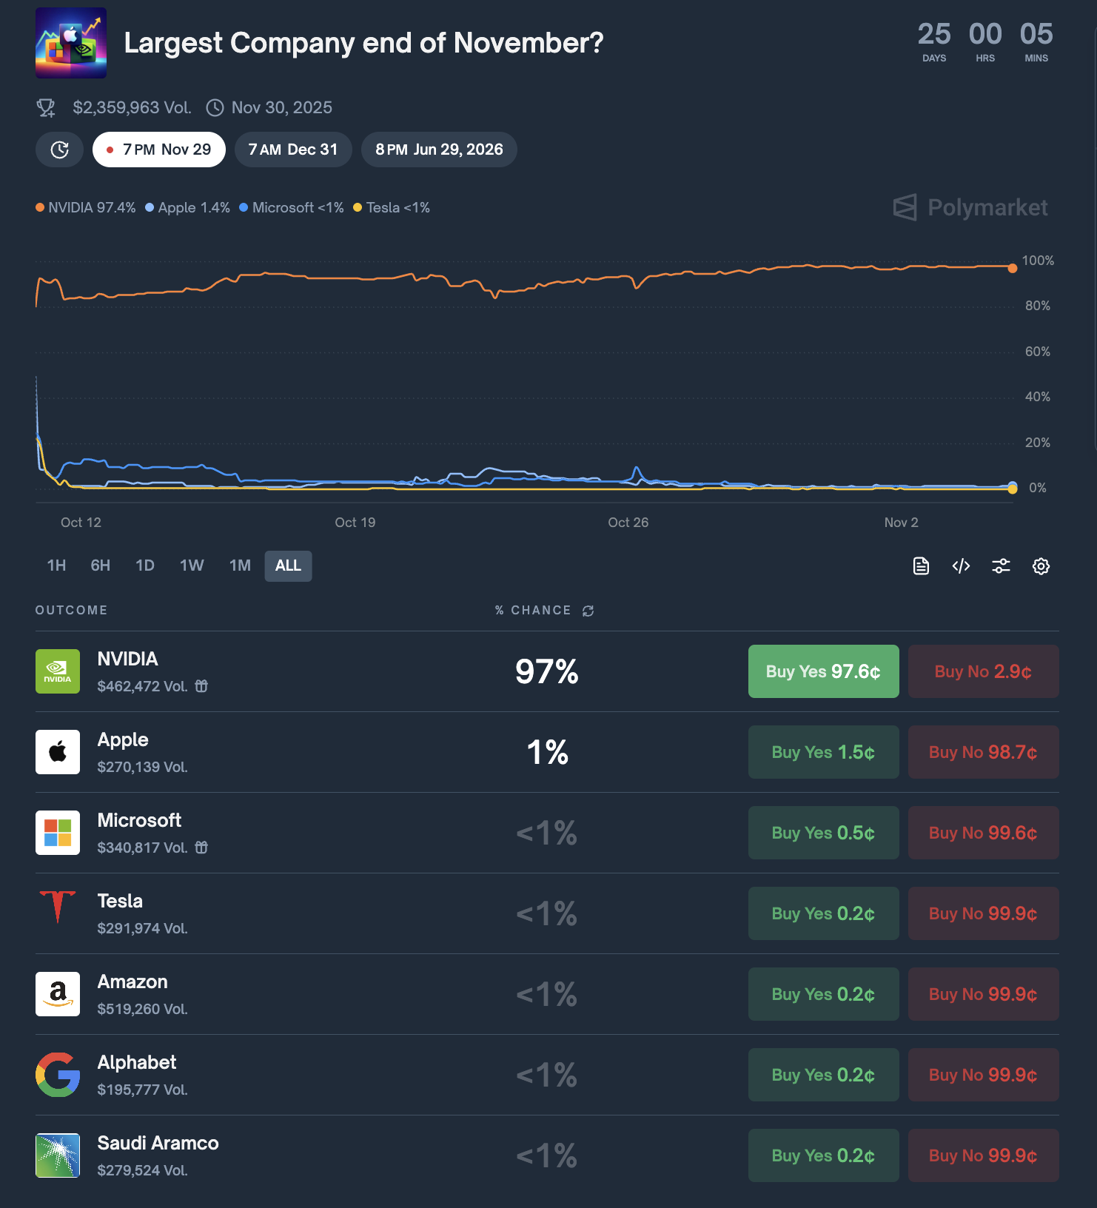
Source: https://polymarket.com/event/largest-company-end-of-november?tid=1762294889899

FinGPT:
NVIDIA edges out Microsoft and Apple to become the largest company by market cap at the end of November 2025, driven by AI dominance, profit acceleration, and investor sentiment. (Correct)

Perplexity:
Based on latest available data through November 2025, NVIDIA tops global market cap, followed closely by Microsoft and Apple.(Correct)

Question2: What price will gold close at in 2025?
Truth: With Most people thinks the gold price will be between 3200 to 4000 dollars per ounce at Nov 4th 7:22pm
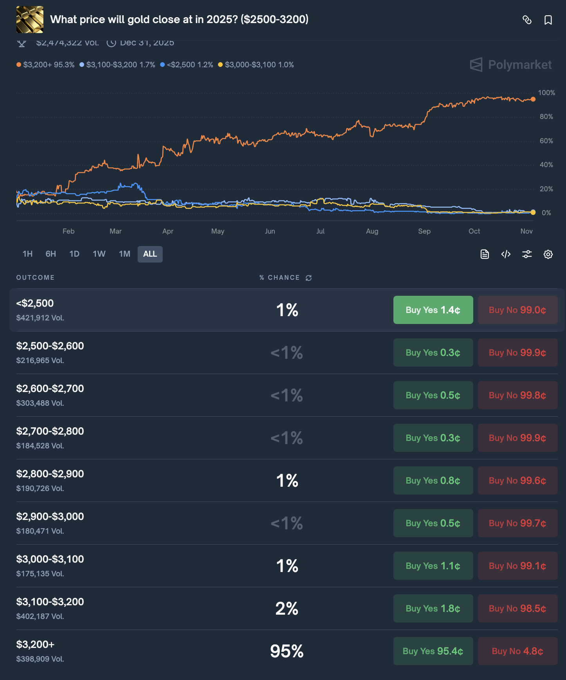
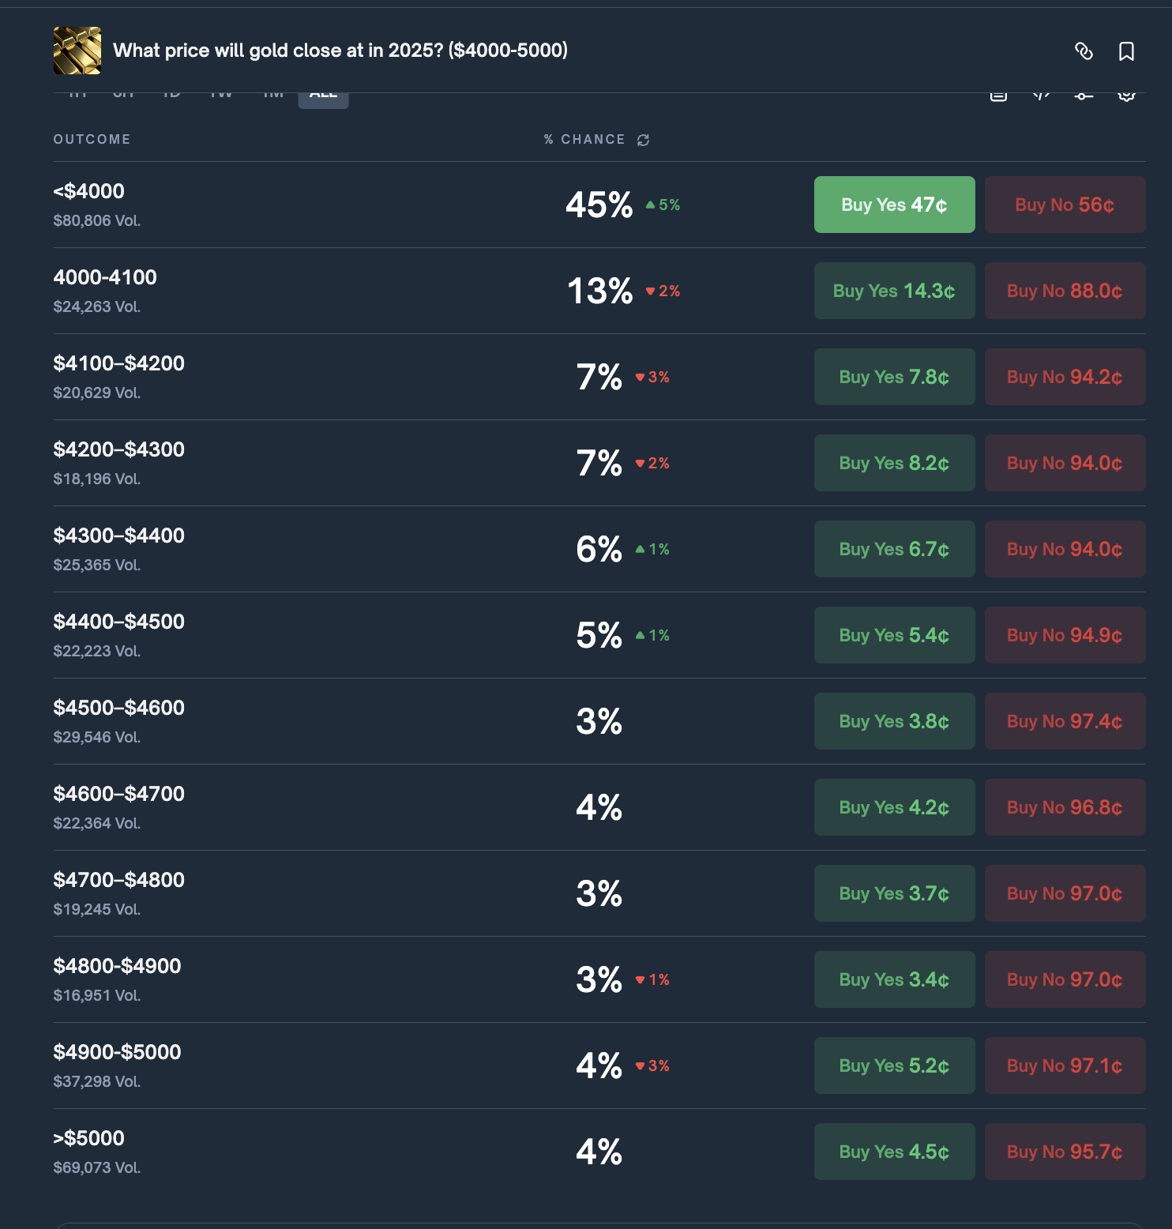
source: https://polymarket.com/event/what-price-will-gold-close-at-in-2025?tid=1762302222780
https://polymarket.com/event/what-price-will-gold-close-at-in-2025-4000-5000?tid=1762301902154

FinGPT:
At the end of 2025, gold is predicted to close around $2,500 per ounce, driven by rate cuts, central bank demand, and safe-haven investor flows. (Incorrect)

Perplexity:
In summary, gold is most likely to close 2025 at or above $4,000 per ounce, with the consensus range being $3,800–$4,600 per ounce, unless market conditions shift dramatically. (correct)

Question3: What will be the 2nd Largest company at the end of November 2025?

Truth: Apple with 76% support rate followed by Microsoft with 22% support rate at Nov 4 7:10 pm
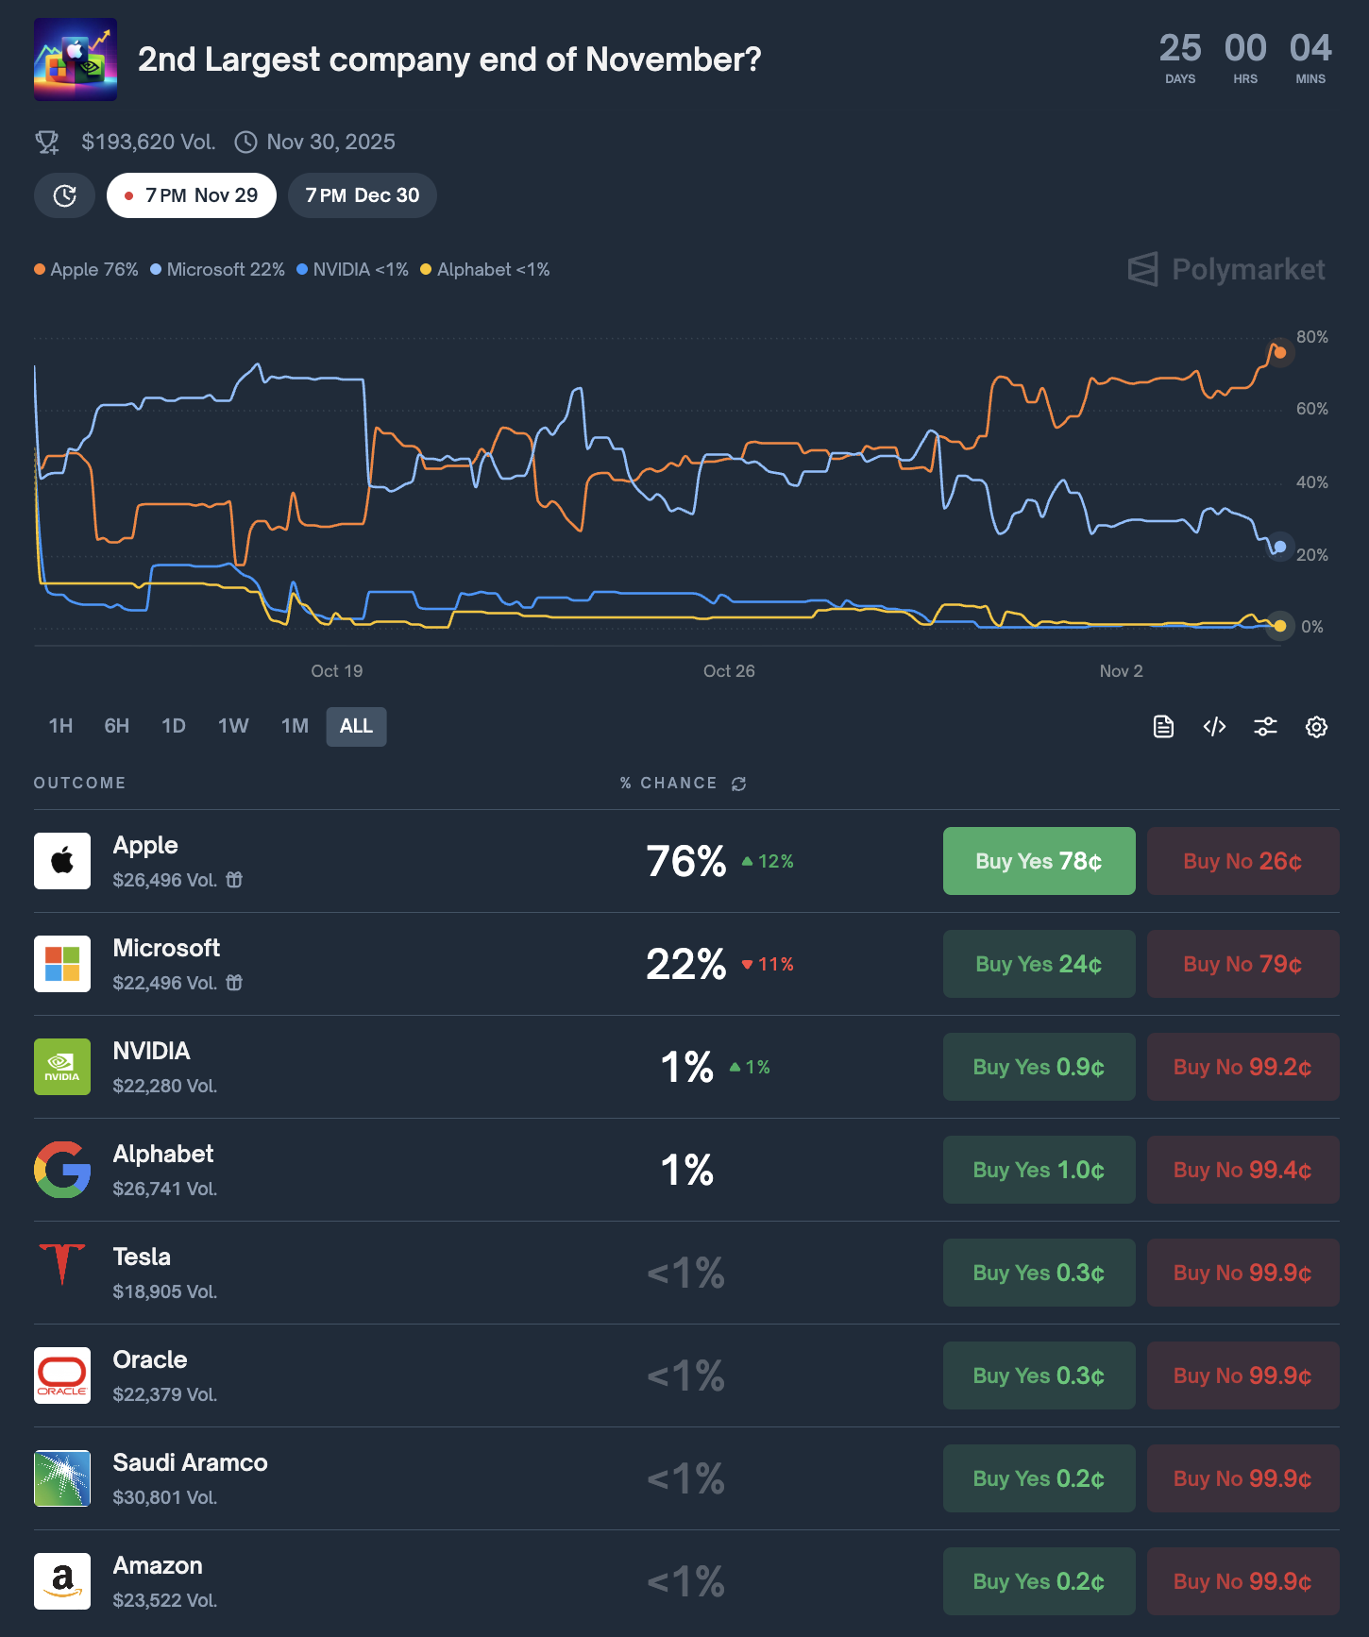
source: https://polymarket.com/event/2nd-largest-company-end-of-november?tid=1762300530754

FinGPT:
💰 Projected Market Caps (End of November 2025)
NVIDIA (NVDA): ~$3.4–3.6 trillion
Microsoft (MSFT): ~$3.2–3.4 trillion
Apple (AAPL): ~$3.0–3.2 trillion
✅ Prediction Summary:
At the end of November 2025, Microsoft will likely be the second-largest company in the world by market capitalization, narrowly behind NVIDIA, with Apple in third place.(correct)

Perplexity:
The second largest company in the world at the end of November 2025 is projected to be Microsoft, based on consensus from current market capitalization rankings and prediction markets.​

Current Market Capitalization Rankings
As of early November 2025, the world’s largest companies by market capitalization are:

NVIDIA: approximately $4.90 trillion

Microsoft: about $3.82 trillion

Apple: close to $4.01 trillion​
(Correct)

Question4: Who will first go to 5k: Gold or ETH?
Truth: 45% chance of Gold, 55% chance of ETH at Nov 4 2025
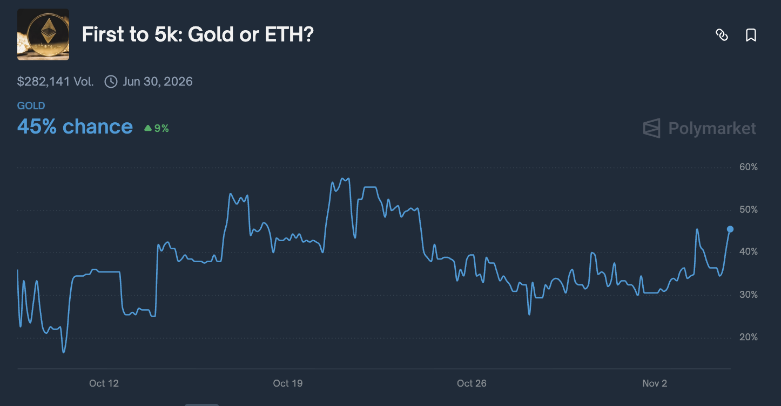
source:
https://polymarket.com/event/first-to-5k-gold-or-eth?tid=1762304003528

FinGPT:
Ethereum (ETH) is far more likely to reach $5,000 first, thanks to its higher volatility, past proximity to that level, and accelerating institutional adoption. Gold would require an extraordinary macro shock to catch up that fast.(incorrect)

Perplexity:
In summary, Ethereum is highly likely to reach $5,000 before gold does based on market sentiment, volatility, and prediction markets as of November 2025.​(incorrect)

Question5: What will Amazon (AMZN) hit in November 2025?
Truth: most people thinks will be above $260 at Nov4 7:50 pm 2025
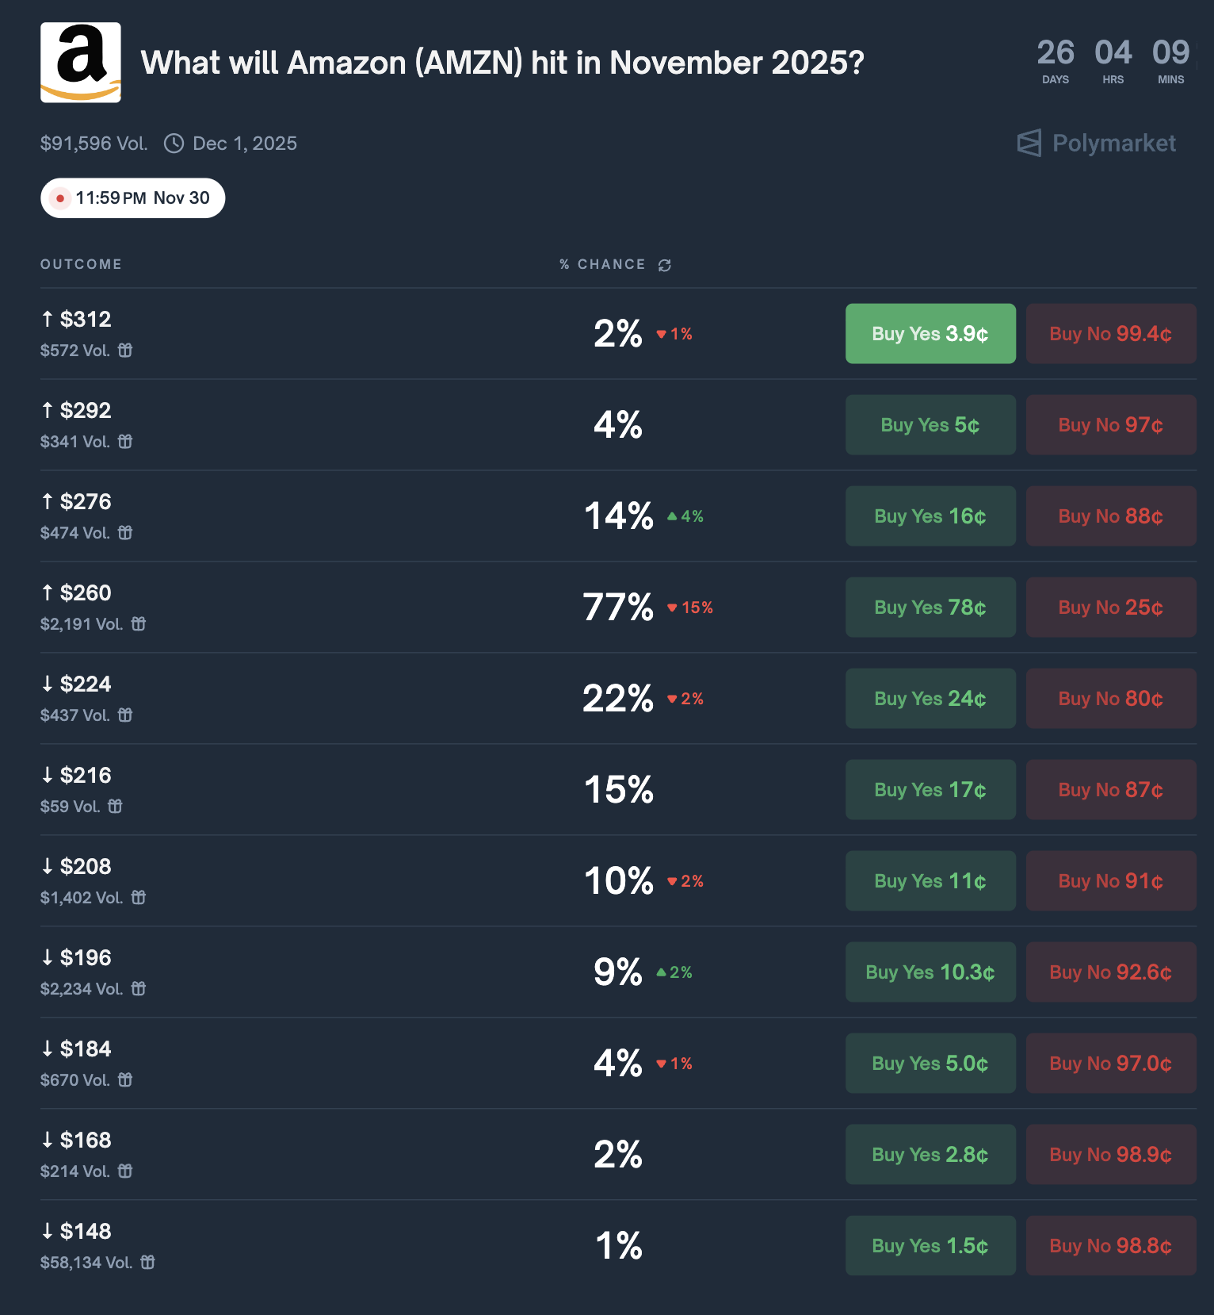
source: https://polymarket.com/event/what-price-will-amzn-hit-in-november-2025?tid=1762303727082

finGPT:
By November 2025, Amazon’s stock (AMZN) is most likely to trade in the \$195 – \$210 range per share — near a **\$2.1 trillion** market capitalization

perplexity:
Based on up-to-date forecasts and analyst consensus, Amazon (AMZN) is expected to finish November 2025 at approximately $249–$262 per share.

